Practical-3

**AIM :** **Generation of Reproducible and Interactive ML Project**

Task 1: Create the Github repository for the house rate prediction project created in practical2

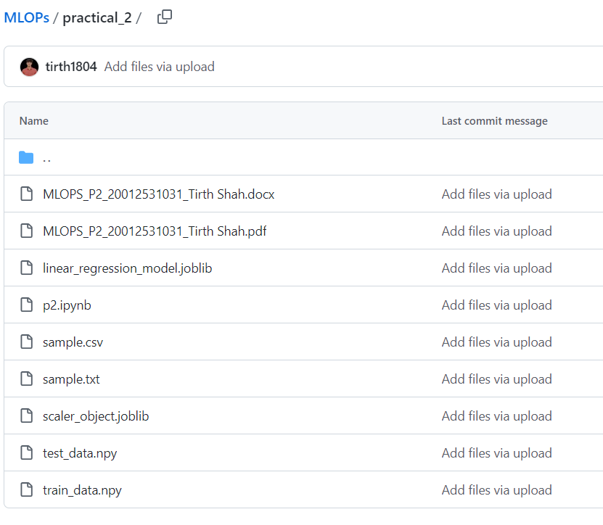

**Task 2:** Integrate your repository with the binder to make your project interactive. (Hint: refer to the following link for the steps:

